Designing of T-Intersection Traffic Signal   
Control System using FSM

Vinayak Prakash Mali

*Kolhapur Institute of Technology’s College of Engineering, Kolhapur*

Maharashtra, India

July 19, 2022

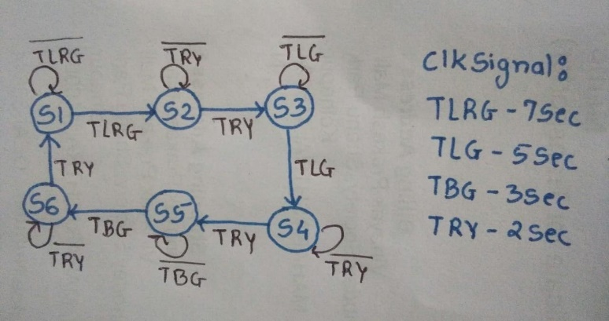***Abstract*—This paper presents the design of a finite state machine that describes a traffic controller at T- Intersection of Road. The aim of the project is to design a traffic controller for a T-intersection roads. The machine needs only clock signal after a particular time and does not need any other input. The design facilitates a trigger for RYG color to indicate traffic signal light according to its state. This FSM are to installed at T- Intersection or three-way intersection roads to control traffic effectively. This FSM can replace the role of human and can automate the task of traffic control. Less labor, efficient and accurate traffic controlling is possible because of traffic signals.**

***Keywords*—T-Intersection Road, Finite State Machine**

1. DESCRIPTION

Finite state machines (FSM) are important class of sequential circuits. They provide memory to silicon and take action with memory. FSM can be implemented either as Mealy where output is a function of present state and current input or Moore where output is a function of present state only. T-intersection traffic signal is real world application of FSM. The FSM takes clock signal after specific timethat indicates the input to change the states of signal. RYG i.e., red yellow and green signal light is changed in respective state after receiving clock signal. The system is activated after receiving the reset signal and making counter zero.

1. STATE DIAGRAM

The state diagram of the T-intersection traffic signal system is shown in figure 2. Six states are used to keep track of six different conditions at T-Intersection, with 7sec, 5 sec, 3sec and 2sec of clk signal accordingly.

S1 - Green signal for LS and RB with other red light.

S2 - Green signal for LS, Yellow signal for RB.

S3 - Green signal for LS, LR.

S4 - Yellow signal for LS, LR.

S5- Green signal for BR.

S6 - Yellow signal for BR.

Figure 1 shows the direction of car movement.

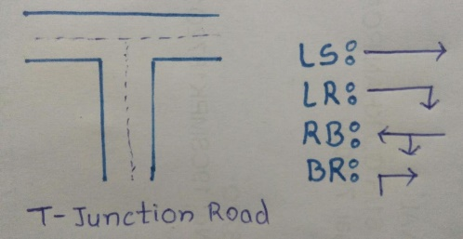

Fig. 1. T-Intersection Traffic Road and Turning Directions

Fig. 2. State diagram for T-Intersection Traffic Signal controller Logic

1. WAVEFORM

The figure 3 shows the sample functioning of the design described in figure 2.

For the first 7sec system is in 0 i.e., state 1 which triggered the LS and RB for green light putting other to red light. For next 3sec system is in S2 state. For next 5sec system is in S3 state which is indicated by 2 in last waveform. And it is continuing as per shown in state diagram.

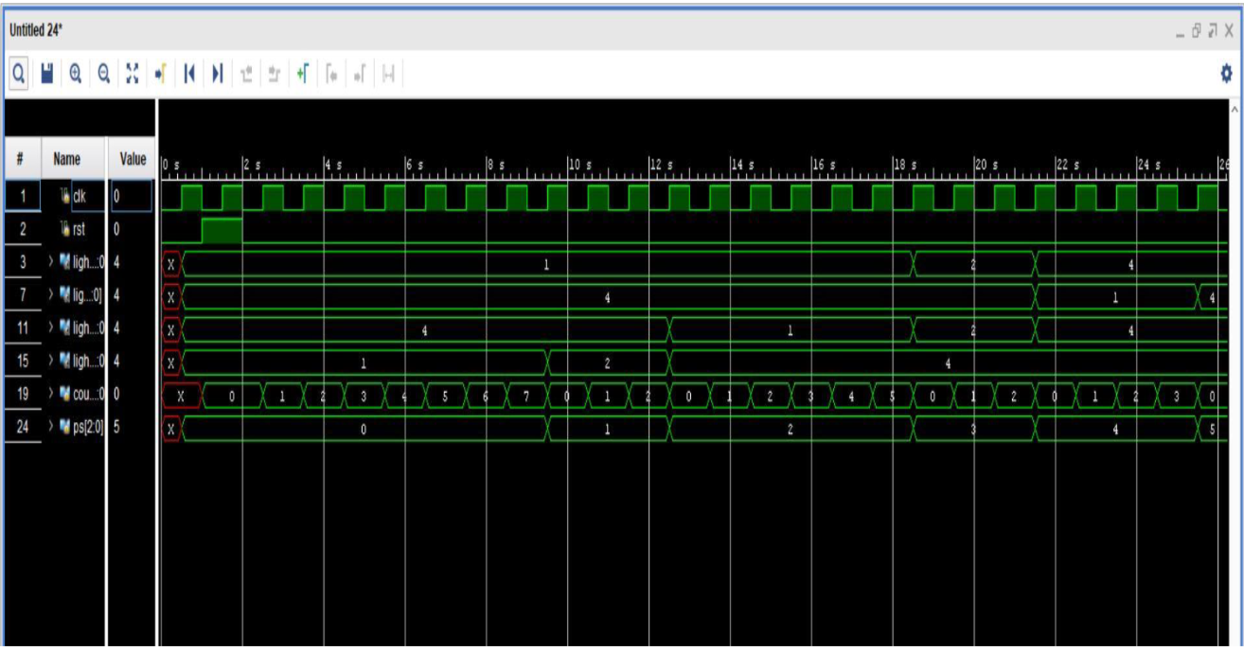

Fig. 3. T-Intersection Traffic Controller waveform

REFERENCES

[1] http://www.asic-world.com/tidbits/verilog_fsm.html

[2] NPTEL lecture on Digital design by Prof. Srinivasan